Sign in/register
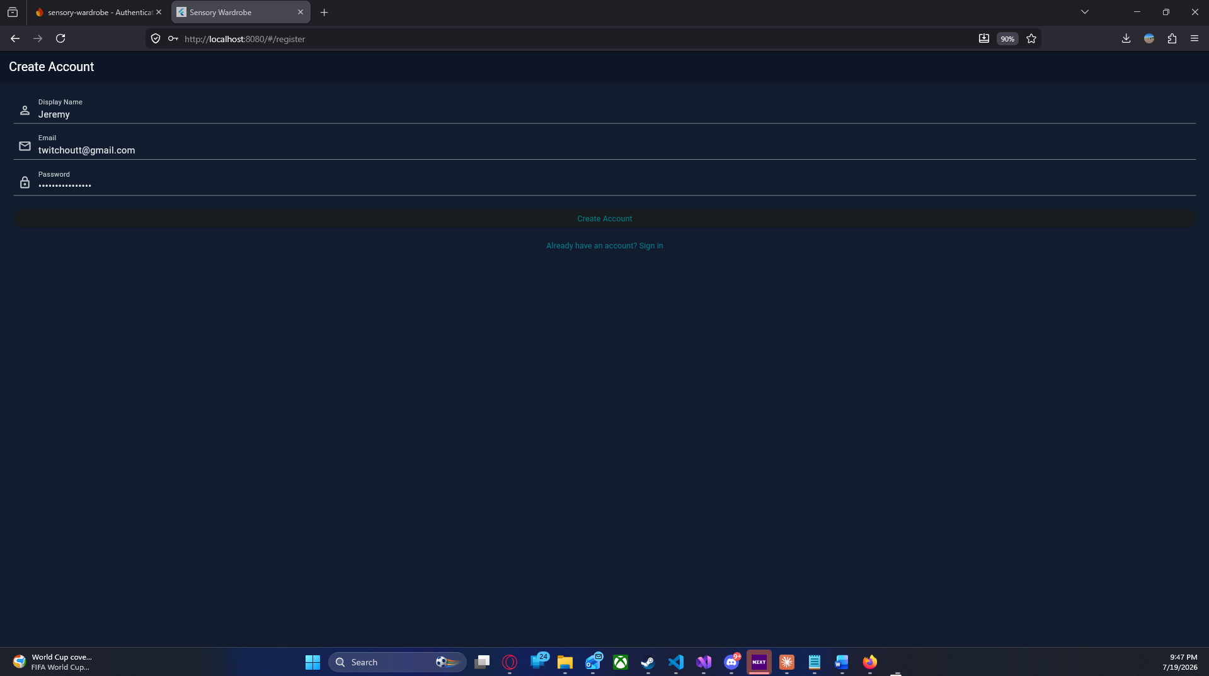
When first hitting the website you will be greated with a sign in/register screen
follow the register one and it will ask you for name, email and password, you will use these to login
Dashboard
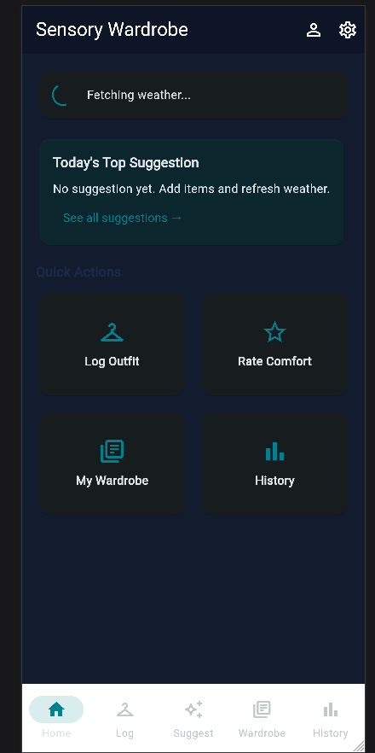
This is the dashboard, here you get an overview of everything on the app. The bottom acts as a navigation tool. Here you can jump between the core features

My wardrobe

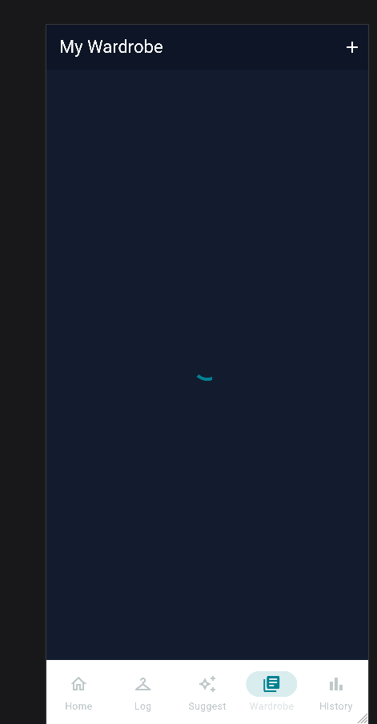
In my wardrobe you can view all your wardrobe items
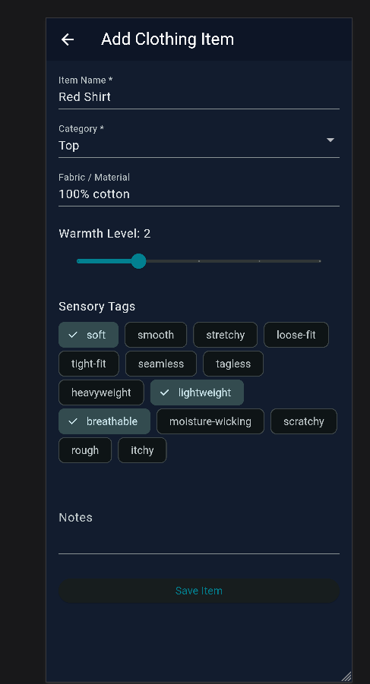
In add clothing items you can add each specific item of clothing
The category drops down to let you chose where these clothing items fit on your person
You can add notes, tags, and comfort level. Once you hit save item it populates in my wardrobe

History
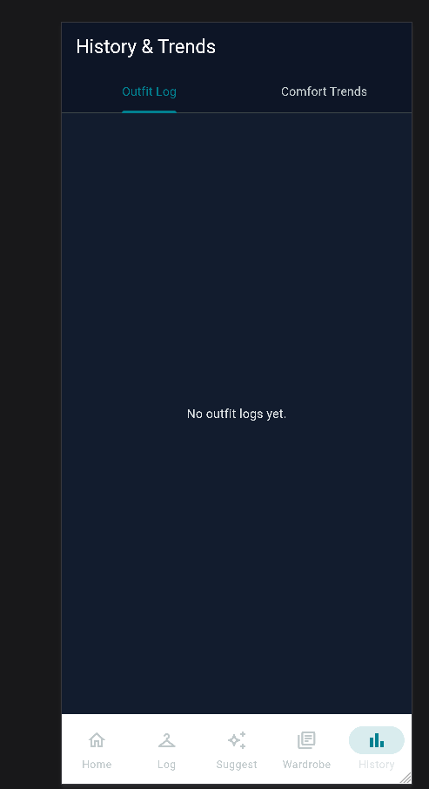
In history in trends, you are able to see what you wore each day and how you rated the outfit that day

Outfit suggestions
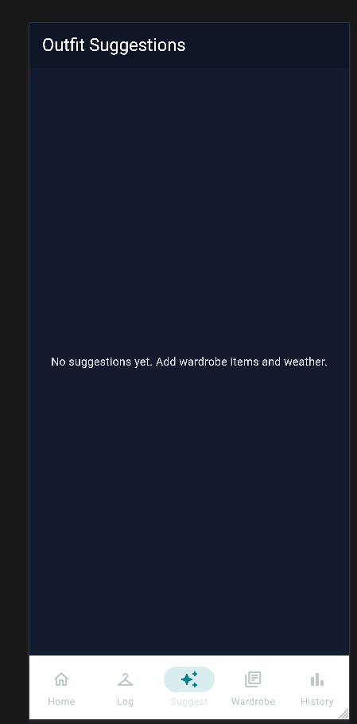
Outfit suggestions grabs your information from history and combines weather data to determine a suggestion for your daily outfit choice
Rate comfort
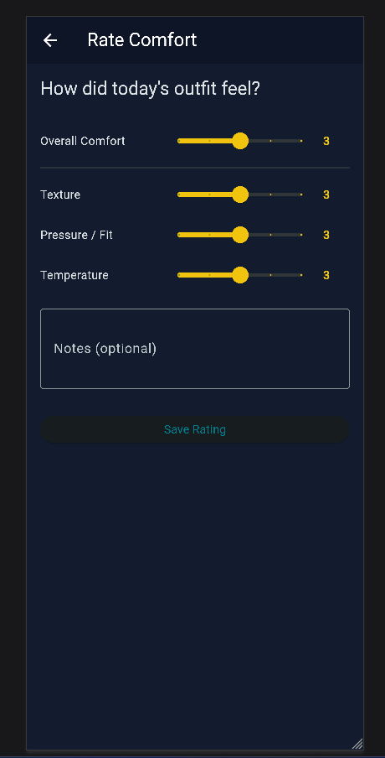
Rate comfort lets you rate the comfort of the outfit that day and leave additional notes

